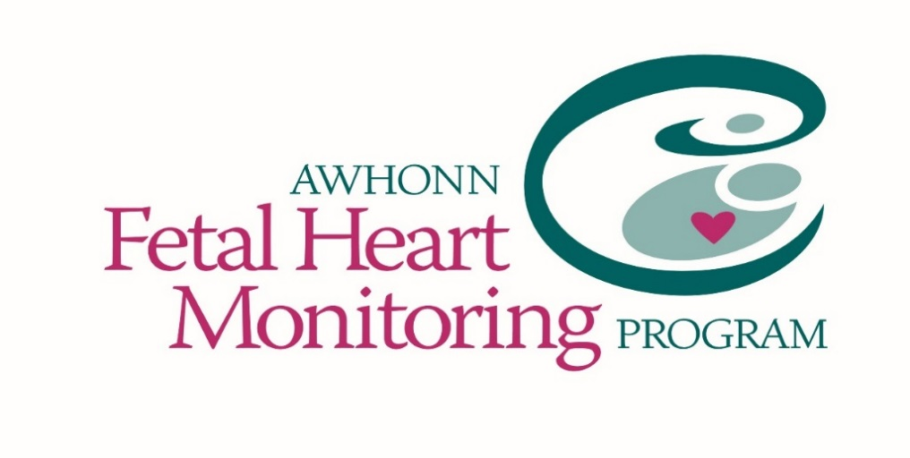

Friday, March 18, 2022
8:00 AM to 4:30 PM
Location: Online
Registration Deadline March 4, 2022

Advanced Fetal Monitoring

Intended Audience
The Advanced Course is designed for perinatal clinicians with at least one year of intrapartum clinical experience. Individuals are expected to assess their own eligibility to participate in the course and should seek counsel and guidance from the Instructor as needed. The Instructor may deny the participant attendance at an Advanced Fetal Monitoring Course if he or she determines the participant does not have the requisite appropriate level of knowledge and skill. Participants who attend the full day of the course are awarded 8 hours of continuing nursing education (CNE) credit or 6 hours of continuing medical education (CME) credit. The course includes an optional posttest with 80% being the requirement for successful completion of the test
Workshop Description
The Advanced Fetal Monitoring Course is a 1-day course that expands on the knowledge and principles that were presented in the Intermediate Fetal Monitoring Course and covers more complex concepts. This course uses a case study approach focusing on the analysis of complicated FHM patterns and characteristics with related case information and includes an optional online test. It is presented in a standardized format that can be used as an educational assessment to validate the knowledge of experienced perinatal clinicians. The course emphasizes the following:
Target Audience/Expected level of learner:
The Advanced Fetal Monitoring Course format is based on adult educational theory. The instructional design incorporates critical thinking and decision-making and is specifically designed for perinatal clinicians with previous FHM experiences.

Online Learners will need
- Pre-register
- Computer access with camera and microphone
- Internet access

The Advanced Fetal Monitoring Course format is based on adult educational theory. The instructional design
For more information contact: Suzette Carthron at 312-942-8610 or
via e-mail: suzette_r_carthron@rush.edu
Registration Fee: $150.00
Price includes: Student packet, CE certificates
Registration Deadline: March 4, 2022 (no refund if cancellations made after this date)

To register please complete Registration Link:

*Rush APC: Registration Link - Advanced FHM Program

Payment Information:

* Credit Card Payment Method Preferred!!!

For other payment methods please contact:
Suzette Carthron at 312-942-8610
or
via e-mail: suzette_r_carthron@rush.edu

*Preparation*
**Students are required to purchase Fetal Heart Monitoring Principles and Practices 5th edition textbook, either the e-book or textbook and review prior to class**

Textbook can be purchased Via
Rush Perinatal Center: $75.00, Free Shipping and Handling
Email: orders@kendallhunt.com
Visit: https://awhonn.kendallhunt.com
Call: 800-338-8290 (7:30 a.m. - 5:00p.m. CT/Monday - Friday)

- Please indicate on registration form if you have purchased the required materials.

